Convolutional Neural Network
Data Set: https://www.cs.toronto.edu/~kriz/cifar.html
(Default Data Set)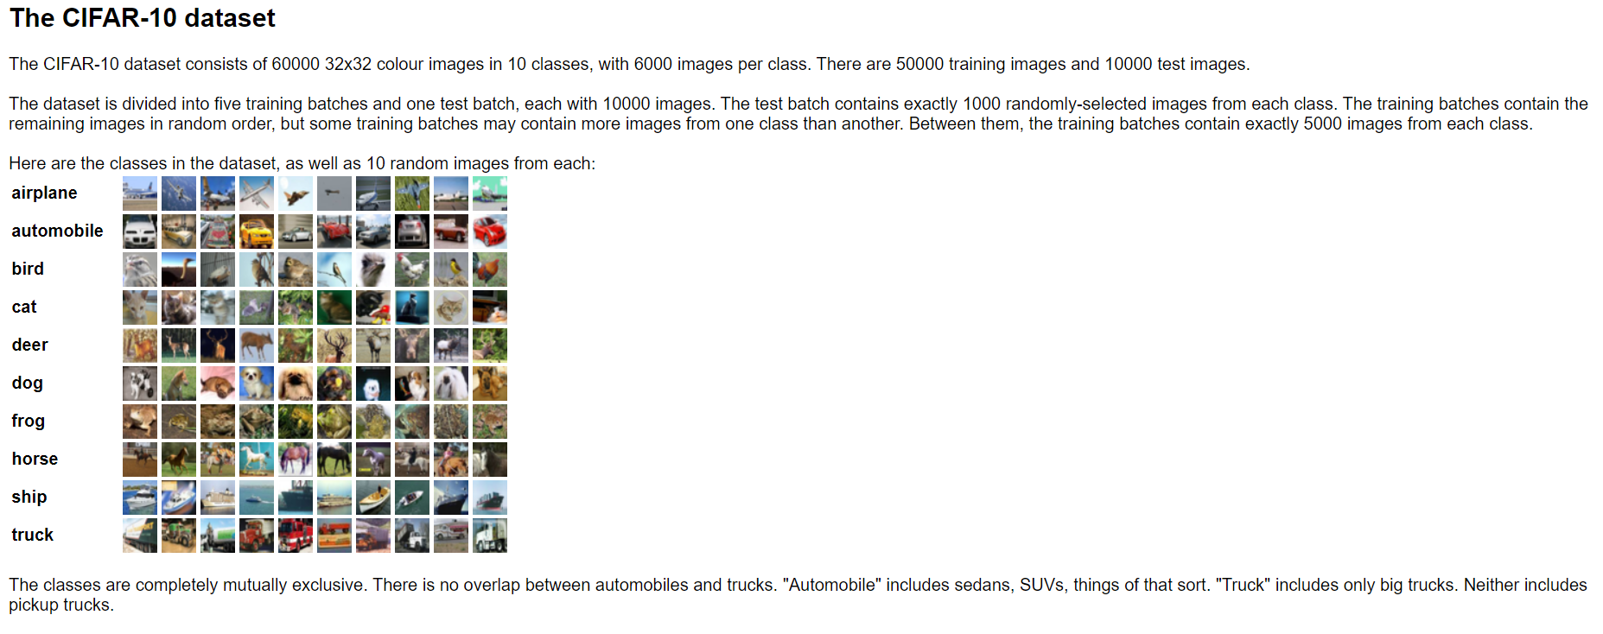

Cost and Loss Function
Cost and loss functions are synonymous (some people also call it error function).
Loss function is a method of evaluating “how well your algorithm models your dataset”. If your predictions are totally off, your loss function will output a higher number. If they’re pretty good, it’ll output a lower number. As you tune your algorithm to try and improve your model, your loss function will tell you if you’re improving or not. ‘Loss’ helps us to understand how much the predicted value differ from actual value
The loss error is computed for a single training example. If we have ‘m’ number of examples then the average of the loss function of the entire training set is called ‘Cost function’.
Cost function (J) = 1/m (Sum of Loss error for ‘m’ examples)
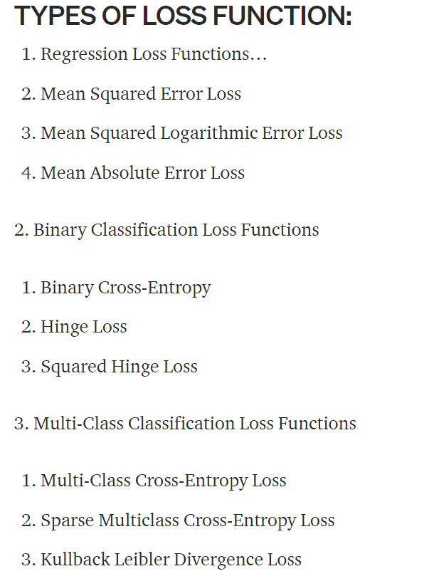

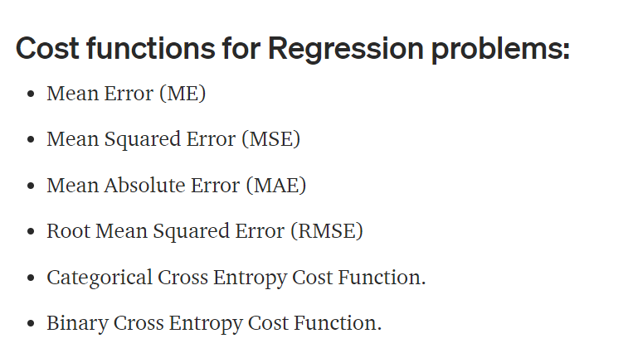

ACTIVATION FUNCTION:
An activation function is a very important feature of an artificial neural network, they basically decide whether the neuron should be activated or not. In artificial neural networks, the activation function defines the output of that node given an input or set of inputs.

Activation function Types:
- Linear function
- Binary Step function
- Non-Linear function

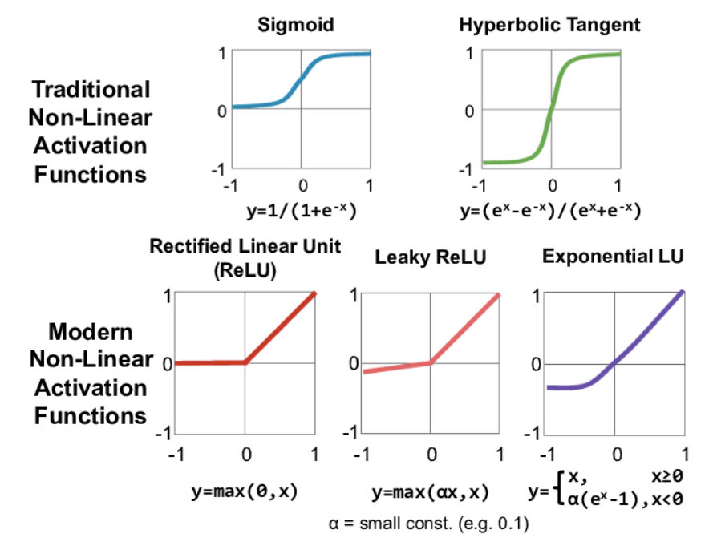

Import Libraries

import tensorflow as tf
from tensorflow import keras
from keras import datasets, layers, models
import matplotlib.pyplot as plt
import numpy as np

Tensor Flow and Keras Version

print(tf.__version__)
print(tf.keras.__version__)

Load Data Set
(X_train, y_train), (X_test,y_test) = datasets.cifar10.load_data()

Print Shape of Training and Test Data Set
(32 by 32 Image 3 for RBG Channel)

print (X_train.shape)
print (X_test.shape)

Print the Dataset
This display array of 32 X 32 X3

print (X_train[0])

Print /Display image
Print image 1 – This is a Truck,

plt.figure(figsize = (5,2))
plt.imshow(X_train[1])
plt.show()

Create a list with all classes of images
classes = ["airplane","automobile","bird","cat","deer","dog","frog","horse","ship","truck"]
print (classes)
Print dependent variable – This is a two-dimensional array.

print (y_train)

Convert Y to one dimension
y_train = y_train.reshape(-1,)
print (y_train)

Create a function to print the image

def plot_sample(X, y, index):
plt.figure(figsize = (15,2))
plt.imshow(X[index])
plt.xlabel(classes[y[index]])

Call the Function
Print the image with class of image

print (plot_sample(X_train, y_train, 1))
print (plot_sample(X_train, y_train, 3))

Normalize the image (Divide by 255- then values will be in the range 0 to 1)

X_train = X_train / 255.0
X_test = X_test / 255.0

Create an ANN model

ann = models.Sequential([
layers.Input(shape=(32,32,3)) ,
layers.Flatten(),
layers.Dense(3000, activation='relu'),
layers.Dense(1000, activation='relu'),
layers.Dense(10, activation='sigmoid')
])
ann.compile(optimizer='SGD',
loss='sparse_categorical_crossentropy',
metrics=['accuracy'])

Fit the Model

ann.fit(x=X_train, y=y_train,
epochs=7, validation_data=(X_test, y_test), verbose=1 )

Model Summary
print (ann.summary())

Predict for X_test
y_pred = ann.predict (X_test)
print (y_pred)

Print classification report for Accuracy

from sklearn.metrics import confusion_matrix , classification_report,accuracy_score

y_pred_classes = [np.argmax(element) for element in y_pred]

print("Accuracy: \n",accuracy_score (y_test,y_pred_classes))
print ()
print("Confusion Matrix: \n",confusion_matrix (y_test,y_pred_classes))
print ()
print("Classification Report: \n", classification_report(y_test, y_pred_classes,zero_division = 0))

Create the ML GaussianNB with less Accuracy compared to ANN

Import Libraries

import matplotlib.pyplot as plt
from keras import datasets
import numpy as np

Load Data Set
(X_train, y_train), (X_test,y_test) = datasets.cifar10.load_data()
print (X_train.shape)
print (X_test.shape)

Create a function to print the image
def plot_sample(X, y, index):
plt.figure(figsize = (15,2))
plt.imshow(X[index])
plt.xlabel(classes[y[index]])

Display different classes
classes = ["airplane","automobile","bird","cat",
"deer","dog","frog","horse","ship","truck"]
print (classes)

Convert Y Train to a one-dimensional Array
y_train = y_train.reshape(-1,)
print (y_train)

Convert Y Test to a one-dimensional Array
y_test = y_test.reshape(-1,)
print (y_test)

Convert X_train and X_test between 0 and 1
X_train = X_train / 255.0
X_test = X_test / 255.0

Display X_train shape
print (X_train.shape)

Convert X_train 3D array to 2D array
32 *32*3=3072
X_train= X_train.reshape (50000,3072)
print (X_train.shape)

Convert X_test 3D array to 2D array
X_test= X_test.reshape (10000,3072)
print (X_test.shape)

Create Gaussian NB
from sklearn.naive_bayes import GaussianNB
GNB = GaussianNB()
GNB.fit(X_train,y_train)
print (GNB)

Display the Prediction
GNB_pred = GNB.predict(X_test)
print (GNB_pred)

Display Accuracy, Confusion Matrix and Classification Report

from sklearn.metrics import accuracy_score,confusion_matrix,classification_report
print ('Accuracy')
print (accuracy_score (y_test, GNB_pred))
print ()
print ('Confusion Matrix')
cm = confusion_matrix (y_test , GNB_pred)
print (cm)
print ()
print ('Classification Report')
print(classification_report (y_test, GNB_pred, zero_division=0))

Create the CNN model for better accuracy

Import Libraries
import tensorflow as tf
from tensorflow import keras
from keras import datasets, layers, models
from keras import datasets
import numpy as np
import matplotlib.pyplot as plt

Load Data Set
(X_train, y_train), (X_test,y_test) = datasets.cifar10.load_data()
print (X_train.shape)
print (X_test.shape)

Create a function to print the image
def plot_sample(X, y, index):
plt.figure(figsize = (15,2))
plt.imshow(X[index])
plt.xlabel(classes[y[index]])

Display different classes
classes = ["airplane","automobile","bird","cat",
"deer","dog","frog","horse","ship","truck"]
print (classes)

Convert Y Train to a one-dimensional Array
y_train = y_train.reshape(-1,)
print (y_train)

Convert Y Test to a one-dimensional Array
y_test = y_test.reshape(-1,)
print (y_test)

Convert X_train and X_test between 0 and 1

X_train = X_train / 255.0
X_test = X_test / 255.0

Display X_train shape

print (X_train.shape)

Create CNN Model

cnn = models.Sequential([
layers.Input(shape=(32,32,3)) ,
layers.Conv2D(filters=32, kernel_size=(3, 3), activation='relu'),
layers.MaxPooling2D((2, 2)),
layers.Conv2D(filters=64, kernel_size=(3, 3), activation='relu'),
layers.MaxPooling2D((2, 2)),
# ANN components
layers.Flatten(),
layers.Dense(3000, activation='relu'),
layers.Dropout(0.5),
layers.Dense(1000, activation='relu'),
layers.Dropout(0.5),
layers.Dense(10, activation= 'softmax')
])

Compile the CNN model

cnn.compile(optimizer='adam',
loss='sparse_categorical_crossentropy',
metrics=['accuracy'])

Create CNN Model
cnn.fit(x=X_train, y=y_train,
epochs=15, validation_data=(X_test, y_test), verbose=1 )
Model Summary
print (cnn.summary())

Evaluate with test Data
cnn.evaluate(X_test,y_test)

Predict for X_test
y_pred = cnn.predict (X_test)
print (y_pred)

Convert y_pred to y_classes to compare with y_test
Armax function is used to get the maximum values

y_classes = [np.argmax(element) for element in y_pred]
print (y_classes)

Print y_test to compare as well
print (y_test)

Compare the Actual and Predicted values
# Check index 1 value

print ("Prediction")
print (classes[y_classes[1]]) # This prediction
print ("\nActual")
plot_sample(X_test, y_test,1) # This is actual
# Check index 20 value

print ("Prediction")
print (classes[y_classes[20]]) # This prediction
print ("\nActual")
plot_sample(X_test, y_test,20) # This is actual

Classification report and Confusion report with CNN

from sklearn.metrics import accuracy_score,confusion_matrix,classification_report
y_pred =cnn.predict(X_test)
y_pred_classes = [np.argmax(element) for element in y_pred]
print ('Accuracy')
print (accuracy_score (y_test, y_pred_classes))
print ()
print("Classification Report: \n", classification_report(y_test, y_pred_classes, zero_division = 0))
cm = confusion_matrix(y_test, y_pred_classes)
print (cm)

Display top 50 Actual and Predicted Values

import pandas as pd
pd.concat ([pd.DataFrame(y_test), pd.DataFrame(y_classes)],axis =1).head(50)

